**KRATOS SQUAD – ANNA UNIVERSITY REGIONAL CAMPUS COIMBATORE**

**PROBLEM STATEMENT**

Current public transportation systems suffer from inefficient information on the routes, leading to delays and passenger dissatisfaction. The absence of timing and seat availability information exacerbates the issue, fostering a reliance on privately owned vehicles, increasing road congestion, and contributing to environmental pollution.

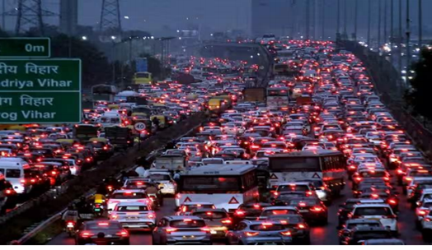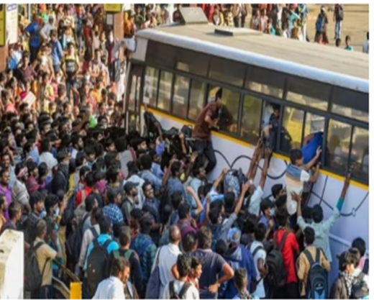

**SOLUTION**

* IoT sensors installed on buses continuously track real-time locations and seat occupancy, with data transmitted to a central server for analysis. Passengers access this information through an intuitive mobile app, providing real-time updates on bus locations, estimated arrival times, and available seats.
* The integration of Google Maps allows users to monitor live bus locations and seat availability via a mobile link.
* RTBTSS promises to make public transportation more reliable, convenient, and user-centric, benefiting both passengers and operators.

**TECHNOLOGY STACK**

* Embedded Systems
* Arduino Programming ( Embedded C )
* App Development ( Language : Kotlin )
* Cloud and Database Management – Blynk Cloud
* Python - Open CV – Image Processing in ESP 32 CAM

**COMPONENTS USED**

* NODE MCU ESP8266
* IR Sensor
* GPS Neo 6M Module
* LCD – Liquid Crystal Display
* Software : Android Studio , Arduino IDE , Blynk Cloud

**WORKFLOW**



**COST DETAILS**

|  |  |  |
| --- | --- | --- |
| **NAME OF COMPONENT** | **QUANTITY** | **RATE** |
| Node MCU ESP8266 | 1 | 380 |
| IR Sensors | 52 | 1560 |
| GPS Neo – 6M Module | 1 | 300 |
| **TOTAL** | | **2240** |

|  |  |  |
| --- | --- | --- |
| **NAME OF COMPONENT** | **QUANTITY** | **RATE** |
| Node MCU ESP8266 | 1 | 380 |
| Camera – Image Processing | 2 | 4000 |
| GPS Neo – 6M Module | 1 | 300 |
| **TOTAL** | | **4680** |